Name: Sarat Das
Enrollment Number: MSE24010
Programme: M.Sc. Economics & Management
Institute: Indian Institute of Information Technology, Lucknow (IIIT Lucknow)
Course Instructor: Prof. Masood Siddiqui

Dynamic Interactions Between Repo Rate, Inflation, GDP Growth, and Money Supply in India

1. Abstract
This study investigates the dynamic relationships between India’s repo rate, inflation (CPI), GDP growth, and money supply (M3) using monthly macroeconomic data. Initial Ordinary Least Squares (OLS) and regularized regressions (Ridge, Lasso, ElasticNet) produced poor results due to non-stationarity, policy-driven spikes, and violation of classical assumptions. After confirming stationarity through Augmented Dickey-Fuller (ADF) tests, a Vector Autoregression (VAR) model was implemented. Impulse Response Functions (IRF) and Forecast Error Variance Decomposition (FEVD) reveal strong monetary policy inertia, limited short-run impact of repo rate on inflation, and meaningful influence on GDP growth and liquidity. The study provides policy insights into India’s monetary transmission mechanism.

2. Introduction
Monetary policy remains one of the core tools used by central banks to influence macroeconomic outcomes. In India, the Reserve Bank of India (RBI) uses the repo rate as its primary policy instrument to control inflation, influence credit availability, and stabilize economic cycles.
Traditional econometric models (such as OLS) often fail to capture the dynamic, lagged, and interdependent nature of macroeconomic variables. Since macroeconomic series such as inflation, GDP growth, and money supply exhibit persistence, trends, and autocorrelation, time-series models—particularly VAR—are more suitable.
This study investigates the dynamic interrelationships between:
- Repo rate changes
- CPI inflation
- GDP growth
- Money supply (M3)
using advanced time-series tools.

3. STAR Method :--
Situation
OLS and machine-learning regression models produced weak results (negative R², failed assumptions). Residual plots showed heavy tails, and repo rate behaved like a policy series, not a smooth economic variable.
Task
Build a statistically correct model that captures dynamic relationships among repo rate, inflation, GDP, and money supply.
Action
- Conducted ADF stationarity tests
- Transformed variables (log-diffs, differencing)
- Built a Vector Autoregression (VAR) model
- Generated IRFs and FEVD
- Interpreted monetary policy transmission
Result
VAR successfully captured dynamic interactions, revealing:
- Strong repo rate inertia
- Weak repo → inflation effect
- Repo → GDP contraction effect
- Monetary policy influences liquidity
This produces a valid macroeconomic model unlike OLS.

4. Research Question
How does India’s repo rate dynamically interact with inflation, GDP growth, and money supply, and how does a monetary policy shock propagate through the economy over time?

5. Hypotheses
H1: Repo rate responds positively to inflation shocks (inflation-targeting).
H2: A repo rate shock reduces GDP growth in the short run (contractionary policy).
H3: A repo rate shock reduces money supply (tight liquidity conditions).
H4: Repo rate is strongly influenced by its own past values (policy inertia).

6. Data Description
- Monthly Indian macroeconomic data
- Variables used:
  - d_repo_rate (monthly change)
  - d_cpi_inflation
  - d_gdp_growth_rate
  - dlog_m3 (log difference of M3)
- Period: ~120 observations
- Source: standard macroeconomic databases (compiled dataset)

7. Methodology
7.1 Regression Approach (Initially Attempted)
OLS, Ridge, Lasso, ElasticNet were attempted with transformed variables.
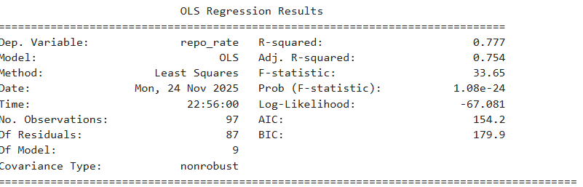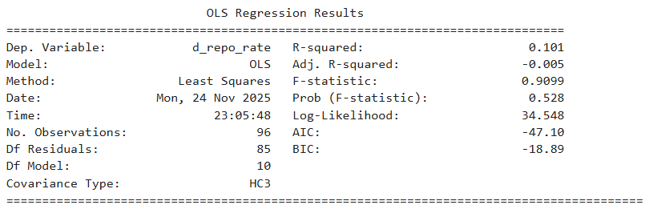
Findings:
- OLS R²: –0.19
- Ridge R²: –0.04
- Lasso R²: –0.015
- Elastic Net R²: –0.017
- 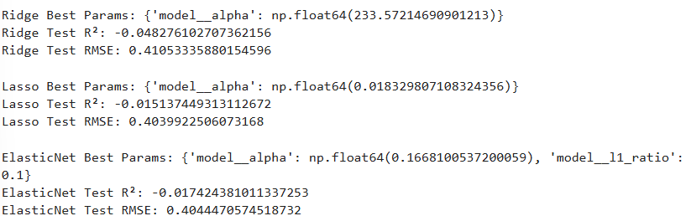
- Residuals: non-normal, heteroscedastic
- Extreme policy-driven outliers → regression invalid
➡ Conclusion: Repo rate cannot be modeled with regression.

7.2 Stationarity Check (ADF Test)
Variable | ADF p-value | Result
d_repo_rate | 0.000136 | Stationary
d_cpi_inflation | 1.2e-16 | Stationary
d_gdp_growth_rate | 1.23e-09 | Stationary
dlog_m3 | 2.58e-22 | Stationary
➡ All variables are stationary → suitable for VAR.

7.3 Vector Autoregression (VAR) Model
Model Selection:
- AIC = –7.06
- HQIC = –5.77
- BIC = –3.88
- Lags selected = 8
Why VAR?
- Captures dynamic interactions
- Uses lagged values of all variables
- Does not impose external structure
- Best for macroeconomic interdependence analysis

8. Results from VAR
8.1 Repo Rate Equation (Key Findings)
Significant lags of d_repo_rate: L1, L3, L4, L7, L8
➡ Repo rate shows high persistence (policy inertia).
Significant other effects:
- L3 inflation → repo rate (marginal)
- L7 M3 → repo rate (liquidity-driven impact)

8.2 CPI Inflation Equation
Significant lag effects from:
- L2 inflation
- L7 inflation
➡ Inflation is highly persistent.
Repo rate does not significantly reduce inflation → weak short-term policy effect.

8.3 GDP Growth Equation
Significant effects from:
- L2 repo rate (negative)
- L2 inflation
- L7 repo rate
➡ Monetary tightening reduces short-term GDP growth.

8.4 Money Supply (M3) Equation
Significant self-lags, plus:
- L1 repo rate
- L1 M3
➡ Repo tightening reduces liquidity.
- 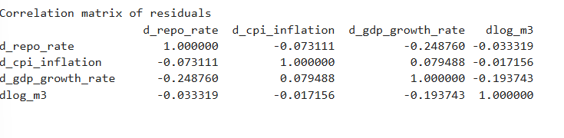

9. Impulse Response Function (IRF) Interpretation
1. Repo-rate shock → Repo rate
- Sharp rise, gradual decline
➡ Monetary policy smoothing
2. Repo-rate shock → Inflation
- Small negative effect
➡ Weak short-run monetary transmission
3. Repo-rate shock → GDP growth
- Negative for several periods
➡ Contractionary effect
4. Repo-rate shock → Money supply (M3)
- Declines → liquidity tightening
➡ Expected monetary response
5. Inflation shock → Repo rate
- Repo rate rises → inflation targeting
6. GDP growth shock → Repo rate
- Repo rate tightening after high growth
- 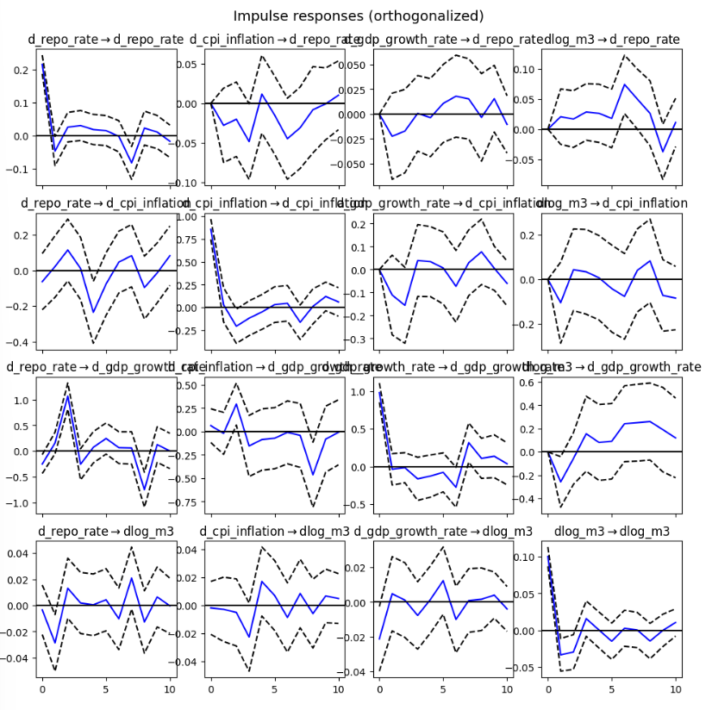

10. Forecast Error Variance Decomposition (FEVD)
Repo Rate FEVD
Over 80% of repo rate variance is explained by its own shocks.
➡ RBI policy is highly self-determined.
Inflation FEVD
Inflation variance almost entirely from its own shocks.
➡ Inflation inertia dominates.
GDP Growth FEVD
Both repo and inflation shocks influence GDP forecasts.
➡ Monetary policy affects real activity.
Money Supply FEVD
Mostly self-driven; strong persistence.
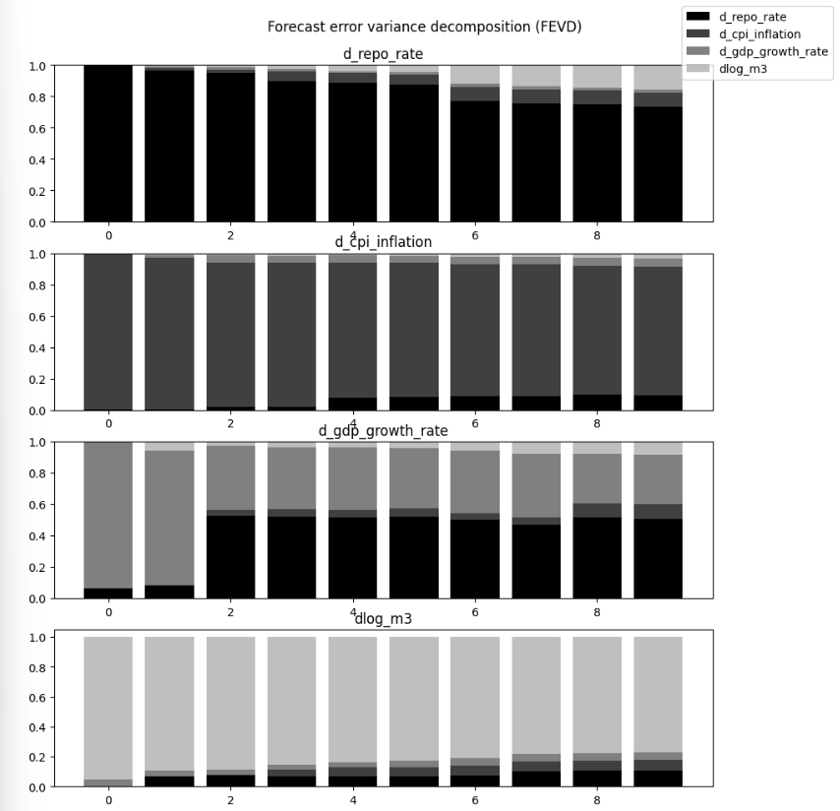

11. Discussion
The results confirm internationally observed patterns in monetary transmission:
- Repo rate has limited effect on short-run inflation
- Repo adjustments strongly influence GDP
- Money supply responds to repo changes but slowly
- Policy shows inertia: RBI adjusts rates gradually
The weak inflation response suggests:
- Supply-driven inflation
- Limited pass-through from policy to prices
- Structural rigidities

12. Policy Implications (Short)
- Inflation control requires structural reforms, not only repo adjustments.
- Repo tightening effectively slows GDP growth, suggesting caution.
- Liquidity management should accompany policy rate changes for better transmission.
- RBI’s inertia is beneficial for macro stability but may delay rapid responses.

13. Conclusion
This study demonstrates that traditional OLS models are inadequate for modeling India’s repo rate dynamics due to non-normality, policy shocks, and dynamic interactions. The VAR model captures realistic macroeconomic relationships and verifies that repo rate, inflation, GDP growth, and money supply influence each other primarily through lagged channels.
Key findings:
- Strong repo rate self-dependence
- Weak repo → inflation link
- Significant repo → GDP impact
- M3 responds to repo rate and its own past values
These results highlight the complexity of India’s monetary transmission mechanism and reinforce the importance of using time-series models for policy analysis.

14. Limitations
- Limited variables (oil prices, fiscal deficit, exchange rates omitted in VAR).
- VAR is reduced-form, not structural (SVAR could improve causality).
- Monthly data may delay detection of short-term policy effects.

